Section I: Scenario Demographics

Scenario Title: | Anaphylaxis with Angioedema
Date of Development: | (17/01/2017)
Target Learning Group: | Juniors (PGY 1 – 2) Seniors (PGY ≥ 3) All Groups

Section II: Scenario Developers

Scenario Developer(s): | Ahmed Taher
Affiliations/Institution(s): | University of Toronto
Contact E-mail (optional): | Ahmed.taher@mail.utoronto.ca

Section III: Curriculum Integration

Learning Goals & Objectives
Educational Goal: | To review a difficult airway scenario requiring cricothyrotomy
CRM Objectives: | Communicate clearly with team members regarding difficult airway planning
Medical Objectives: | - Efficiently treats anaphylaxis in an organized manner, including the prioritization of epinephrine administration  - Recognizes and plans appropriately for the management of a difficult airway  - Recognizes the need for surgical airway and successfully performs a surgical cricothyrotomy

Case Summary: Brief Summary of Case Progression and Major Events
A 45-year-old patient who has already been seen in the ED begins treatment for pyelonephritis with IV antibiotics. Soon after initiated, she develops stridor and respiratory distress, as part of an anaphylactic reaction. The team is called into the room to assess the patient. After standard anaphylaxis treatment is given, the airway is still of concern. Intubation attempts are not successful and the patient will need a surgical airway.

References
http://lifeinthefastlane.com/ccc/anaphylaxis/
https://www.aaaai.org/Aaaai/media/MediaLibrary/PDF%20Documents/Practice%20and%20Parameters/Anaphylaxis-Practice-Parameter-2014.pdf
https://www.ncbi.nlm.nih.gov/pmc/articles/PMC1343032/
http://militarymedicine.amsus.org/doi/abs/10.7205/MILMED.172.12.1228

Section IV: Scenario Script

A. Clinical Vignette: To Read Aloud at Beginning of Case
You are working a night shift at your local Emergency Department. You are called STAT to the bedside of a patient in the department who was seen by your colleague earlier and has recently been started on IV ceftriaxone for a pyelonephritis. You recall from handover that this is a 45-year-old previously healthy female patient with a diagnosis of a UTI two weeks ago, who returned after failing treatment and was diagnosed with pyelonephritis today. The nurse tells you she started the IV antibiotics and fluids 20 min ago, and then started to experience respiratory distress and a “full body rash”.
B. Scenario Cast & Realism
Patient: | Computerized Mannequin |  |  |  |  | Realism:  Select most important dimension(s) |  |  | Conceptual
 | Mannequin |  |  |  |  |  |  |  | Physical
 | Standardized Patient |  |  |  |  |  |  |  | Emotional/Experiential
 | Hybrid |  |  |  |  |  |  |  | Other:
 | Task Trainer (for Cric) |  |  |  |  |  |  |  | N/A
Confederates | Brief Description of Role
Nurse | Assist with delegated tasks, cue learners as to patient’s respiratory status and appearance
C. Required Monitors
EKG Leads/Wires |  |  | Temperature Probe |  |  |  | Central Venous Line
NIBP Cuff |  |  | Defibrillator Pads |  |  |  | Capnography
Pulse Oximeter |  |  | Arterial Line |  |  |  | Other:
D. Required Equipment
Gloves |  |  | Nasal Prongs |  |  |  | Scalpel
Stethoscope |  |  | Venturi Mask |  |  |  | Tube Thoracostomy Kit
Defibrillator |  |  | Non-Rebreather Mask |  |  |  | Cricothyroidotomy Kit
IV Bags/Lines |  |  | Bag Valve Mask |  |  |  | Thoracotomy Kit
IV Push Medications |  |  | Laryngoscope |  |  |  | Central Line Kit
PO Tabs |  |  | Video Assisted Laryngoscope |  |  |  | Arterial Line Kit
Blood Products |  |  | ET Tubes |  |  |  | Other: bougie
Intraosseous Set-up |  |  | LMA |  |  |  | Other: 6-0 ETT
E. Moulage
-Urticaria
-If mannequin allows: angioedema

F. Approximate Timing
Set-Up: |  | 10min |  | Scenario: | 15min |  |  | Debriefing: |  | 15min

Section V: Patient Data and Baseline State

A. Patient Profile and History
Patient Name: Anna Palmer |  |  |  |  |  | Age: 45 |  |  |  |  |  |  |  | Weight: 70kg
Gender: M F |  |  |  |  |  | Code Status: Full code
Chief Complaint: Flank Pain, fever
History of Presenting Illness: Dysuria and treatment for UTI 2 weeks ago. Symptoms worsening with new onset fever, nausea and vomiting. Your colleague in the ED diagnosed her with pyelonephritis, has started IV ceftriaxone, and the general medicine team has been consulted but hasn’t been by to assess yet. Twenty minutes after starting the antibiotics, she began to develop stridor, respiratory distress and a pruritic rash.
Past Medical History: |  | Healthy |  |  |  |  | Medications: |  |  |  |  | Recent nitrofurantoin
Allergies: None known
Social History: Lives with partner
Family History: Non-contributory
Review of Systems: |  | CNS: |  |  | Feeling Faint
 |  | HEENT: |  |  | Swollen lips, tongue, throat feels “tight”
 |  | CVS: |  |  | No chest pain, but does feel a little dizzy
 |  | RESP: |  |  | Feels hard to breathe
 |  | GI: |  |  | Feels nauseous
 |  | GU: |  |  | Nil
 |  | MSK: |  |  | Nil |  |  |  |  |  |  |  | INT: |  | Pruritic rash
B. Baseline Simulator State and Physical Exam
No Monitor Display |  |  |  | Monitor On, no data displayed |  |  |  |  |  |  | Monitor on Standard Display
HR: 130/min |  |  | BP: 100/65 |  |  |  |  | RR: 30/min |  |  |  |  |  |  | O₂SAT: 88% on room air
Rhythm: Sinus Tach |  |  | T: 37.3ºC |  |  |  |  | Glucose: 8.2mmol/L |  |  |  |  |  |  | GCS: 15 (E4 V5 M6)
General Status: Notable respiratory distresses with 3-4 word dyspnea
CNS: | Anxious but alert
HEENT: | Angioedema (swollen tongue, lips). Clear stridor.
CVS: | Normal heart sounds, no murmur. Normal peripheral pulses. One peripheral IV in situ.
RESP: | Stridorous. Also bilateral wheezes and in-drawing
ABDO: | No tenderness
GU: | N/A
MSK: | N/A |  |  |  |  |  |  |  | SKIN: | Widespread urticarial rash

Section VI: Scenario Progression
Scenario States, Modifiers and Triggers
Patient State | Patient Status | Learner Actions, Modifiers & Triggers to Move to Next State
1. Baseline State  Rhythm: sinus tach  HR: 130/min  BP: 100 /65  RR: 30/min  O₂SAT: 88% RA  T: 37.3 ºC | Patient in severe respiratory distress. Speaking 3-4 word sentences, audible stridor, swollen lips and tongue. | Learner Actions  - Apply oxygen and monitors  - Obtain 2nd IV  - Initiate IV NS 1L bolus  - Discontinue antibiotics  - Epinephrine 0.5mg IM  - Solumedrol 125mg IV x 1  - Ventolin 5mg nebulized  - Consider 5mg nebulized epinephrine  - ± Benadryl 50mg iv (low priority)  - ± Ranitidine 50 mg iv (low priority) | Modifiers  Changes to patient condition based on learner action  - O₂ placed Sats to 91%  - Epi, ventolin given HR 150  - If Abx still going at 3 min, RN asks “should we stop the antibiotics?”  Triggers  For progression to next state  - Consideration of intubation  2. Peri-Intubation  - No epi given or no discussion of airway management by 5 min  3. Desaturating
2. Peri-Intubation  HR: 150/min  BP: 100/65  RR: 20/min  O₂SAT: 91% | Respiratory distress, patient getting fatigued – unable to talk, baseline stridor | Learner Actions  - Airway assessment  - Identify difficult airway  - Call for help (extra ERP, anesthesia, ENT)  - Prepare intubation equipment, including back-ups (DL, VL, bougie & LMA in room)  - Call for surgical airway kit in room, prep equipment, prep neck  - Push dose pressor at bedside  - Ketamine 1-2mg/kg ± airway - ± Airway topicalization  - Consider apneic oxygenation  - Consider epinephrine infusion | Modifiers  - Propofol used BP to 70/50  - Paralytic given unable to bag patient, O2 sats drop to 60%  Triggers  - Intubation attempt  4. Intubation  - Attempt cricothyrotomy  5. Cricothyrotomy
3. Desaturating  HR: 150/min  BP: 100/65  RR: 20/min  O₂SAT: 85% | Same as previous state | Learner Actions  - Epinephrine 0.5mg IM  - Ventolin 5mg nebulized  - Consider 5mg nebulized epinephrine | Modifiers  - If no move to airway management 3 min into state RN to prompt “Are you going to intubate?”  Triggers  - Consideration of intubation  2. Peri-Intubation
4. Intubation  HR: 150/min  BP: 100/65  RR: 20/min shallow  O₂SAT: 85% (will drop to 70% after first attempt) | Patient deteriorates despite mgmt (Sats drop with any intubation attempt, do not rise with BVM) | Learner Actions  - Attempt intubation – (grade 4 view)  - Verbalize need for cric | Modifiers  - 1st intubation attempt “grade IV view,” SpO2 70%  - BVM after attempt SpO2 75%  - 2nd attempt SpO2 60%  Triggers  - Prepare for cric5. Cric
5.Cricothyrotomy  HR: 120  BP: 100/65  RR: 5/ shallow  O2 sat: 65% |  | Learner Actions  - Analgesia/sedation prior to cric (if not yet given)  - Prep the neck  - Vertical skin incision over cricothyroid membrane  - Blunt dissection through subcutaneous tissue  - Horizontal incision through cricothyroid membrane  - Dilate with gloved finger  - Pass bougie into trachea beside finger  - Pass ETT over bougie and intubate trachea | Modifiers  - Any method of surgical airway is acceptable  Triggers  - Cric successful 6. Resolution
6. Resolution  HR: 110  BP: 115/65  RR: 12  O2 sat: 95% | Patient cric +/- sedated | Learner Actions  - Confirm placement (breath sounds, ETCO2, CXR)  - Consult ICU  - ± Epinephrine infusion  - Initiate sedation | END CASE PRN

Section VII: Supporting Documents, Laboratory Results, & Multimedia

Laboratory Results
None provided.

Images (ECGs, CXRs, etc.)
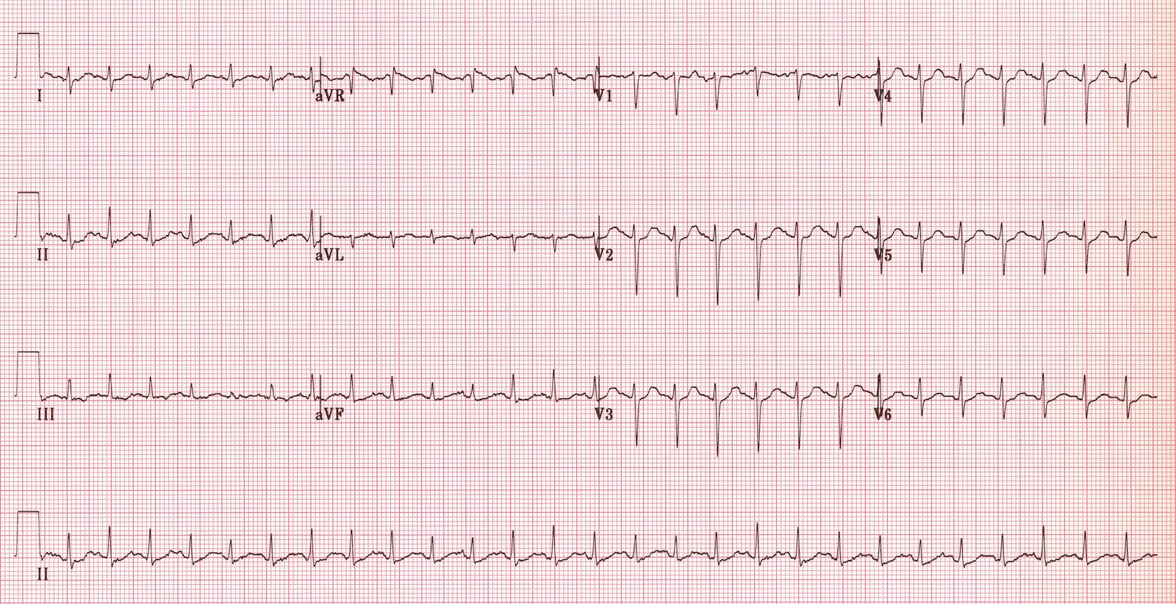  (ECG source: http://i0.wp.com/lifeinthefastlane.com/wp-content/uploads/2011/12/sinus-tachycardia.jpg) | 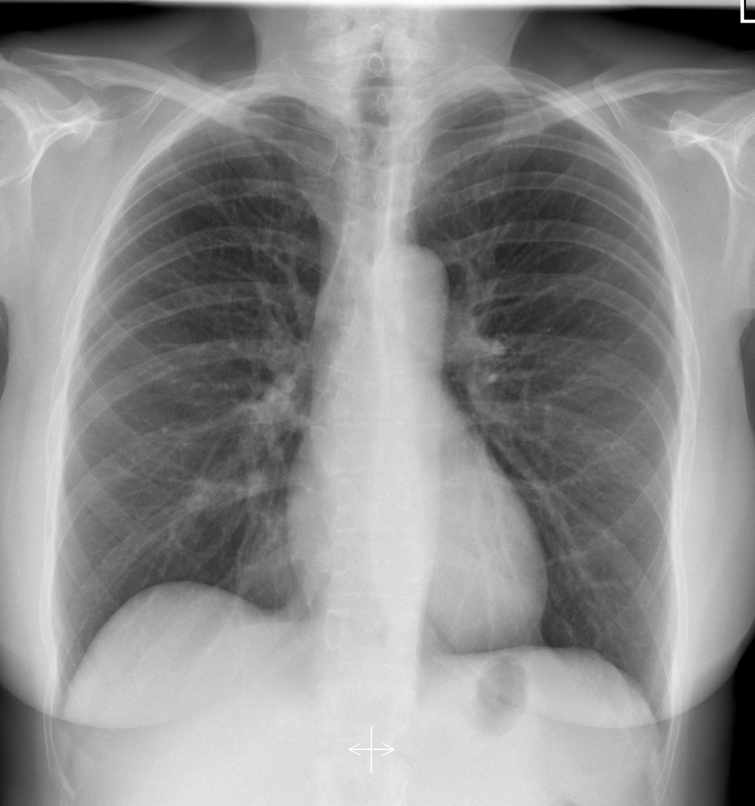  (CXR source: https://radiopaedia.org/cases/normal-chest-radiograph-female)
Ultrasound Video Files (if applicable)
None provided.

Section VIII: Debriefing Guide

General Debriefing Plan
Individual | Group |  | With Video | Without Video
Objectives
Educational Goal: |  | To review a difficult airway scenario requiring cricothyrotomy
CRM Objectives: |  | Communicate clearly with team members regarding difficult airway planning
Medical Objectives: |  | - Efficiently treats anaphylaxis in an organized manner, including the prioritization of epinephrine administration  - Recognizes and plans appropriately for the management of a difficult airway  - Recognizes the need for surgical airway and successfully performs a surgical cricothyrotomy
Sample Questions for Debriefing
- How did the team initially approach the airway management task? Did the team decide to avoid any particular agents?
- What equipment should be available at the bedside for an emergency cricothyrotomy?
- What are the features of difficult cricothyrotomy? Any contraindications to cricothyrotomy?
- How did you feel in making the decision to perform a cricothyrotomy? Were there any steps you would improve upon thinking about the case now?
- Was there any hesitation in performing the cricothyrotomy? Why do you think this is?
- How can a team ensure that a critical procedure, such as a cric, is performed in a timely fashion? Are there any communication tactics that can be used?
Key Moments
Recognition of anaphylaxis and initiation of treatment
Recognition of difficult airway
Recognition of failed intubation and need for surgical airway

